ELCT 302
Laboratory Report #_
Laboratory Exercise Title
Group #
Date

I hereby certify that I have complied
with the Spirit and the Letter
of the Carolinian Creed
in preparing this report

_________________Your signature here_______________
Your name typed here

_________________Your signature here_______________
Your name typed here

Department of Electrical Engineering
University of South Carolina
Columbia, SC 29208

Abstract
[][][][] [][][][] [][][][] [][][][] [][][][] [][][] [][][][][][][] [][][][] [][][] [][][][] [][][][][] [][][][] [][][] [] [][][][][] [][][][] [][][][][] [][] [][] [][][][][][][] [][][] [][][][] [][][][][] [][] [][][][] [][][] [][][][] [][][] [][][][][][][] [][][][][][][] [][][][][][][] [][][][][][][] [][][][][][][] ……..
Table of Contents
Table of Figures……...…………………………………………………………………………...3
I Introduction 4
A. Sub-heading 4
B. Sub-heading 4
II Theory 4
A. Sub-heading 4
B. Sub-heading 4
III Experimental or Procedure 4
A. Sub-heading 4
B. Sub-heading 4
IV Discussion / Results 4
A. Sub-heading 4
B. Sub-heading 5
V Conclusions 5
A. Sub-heading 5
B. Sub-heading 5
I Appendix 6
A. Resistance Table 6
B. Graph of Integration Methods 7
II References 8

Table of Figures
Figure 1 – A graph of integration methods simulating the transient waveforms of a RL circuit 7

Laboratory Exercise Title

Introduction

Sub-heading
[][][][] [][][][] [][][][] [][][][] [][][][] [][][] [][][][][][][] [][][][] [][][] [][][][] [][][][][] [][][][] [][][] [] [][][][][] [][][][] [][][][][] [][] [][] [][][][][][][] [][][] [][][][] [][][][][] [][] [][][][] [][][] [][][][] [][][] [][][][][][][] [][][][][][][] [][][][][][][] [][][][][][][] [][][][][][][] ……..

Sub-heading
[][][][] [][][][] [][][][] [][][][] [][][][] [][][] [][][][][][][] [][][][] [][][] [][][][] [][][][][] [][][][] [][][] [] [][][][][] [][][][] [][][][][] [][] [][] [][][][][][][] [][][] [][][][] [][][][][] [][] [][][][] [][][] [][][][] [][][] [][][][][][][] [][][][][][][] [][][][][][][] [][][][][][][] [][][][][][][] ……..

Theory

Sub-heading
[][][][] [][][][] [][][][] [][][][] [][][][] [][][] [][][][][][][] [][][][] [][][] [][][][] [][][][][] [][][][] [][][] [] [][][][][] [][][][] [][][][][] [][] [][] [][][][][][][] [][][] [][][][] [][][][][] [][] [][][][] [][][] [][][][] [][][] [][][][][][][] [][][][][][][] [][][][][][][] [][][][][][][] [][][][][][][] ……..

Sub-heading
[][][][] [][][][] [][][][] [][][][] [][][][] [][][] [][][][][][][] [][][][] [][][] [][][][] [][][][][] [][][][] [][][] [] [][][][][] [][][][] [][][][][] [][] [][] [][][][][][][] [][][] [][][][] [][][][][] [][] [][][][] [][][] [][][][] [][][] [][][][][][][] [][][][][][][] [][][][][][][] [][][][][][][] [][][][][][][] ……..

Experimental or Procedure

Sub-heading
[][][][] [][][][] [][][][] [][][][] [][][][] [][][] [][][][][][][] [][][][] [][][] [][][][] [][][][][] [][][][] [][][] [] [][][][][] [][][][] [][][][][] [][] [][] [][][][][][][] [][][] [][][][] [][][][][] [][] [][][][] [][][] [][][][] [][][] [][][][][][][] [][][][][][][] [][][][][][][] [][][][][][][] [][][][][][][] ……..

Sub-heading
[][][][] [][][][] [][][][] [][][][] [][][][] [][][] [][][][][][][] [][][][] [][][] [][][][] [][][][][] [][][][] [][][] [] [][][][][] [][][][] [][][][][] [][] [][] [][][][][][][] [][][] [][][][] [][][][][] [][] [][][][] [][][] [][][][] [][][] [][][][][][][] [][][][][][][] [][][][][][][] [][][][][][][] [][][][][][][] ……..

Discussion / Results

Sub-heading
[][][][] [][][][] [][][][] [][][][] [][][][] [][][] [][][][][][][] [][][][] [][][] [][][][] [][][][][] [][][][] [][][] [] [][][][][] [][][][] [][][][][] [][] [][] [][][][][][][] [][][] [][][][] [][][][][] [][] [][][][] [][][] [][][][] [][][] [][][][][][][] [][][][][][][] [][][][][][][] [][][][][][][] [][][][][][][] ……..

Sub-heading
[][][][] [][][][] [][][][] [][][][] [][][][] [][][] [][][][][][][] [][][][] [][][] [][][][] [][][][][] [][][][] [][][] [] [][][][][] [][][][] [][][][][] [][] [][] [][][][][][][] [][][] [][][][] [][][][][] [][] [][][][] [][][] [][][][] [][][] [][][][][][][] [][][][][][][] [][][][][][][] [][][][][][][] [][][][][][][] ……..

Conclusions

Sub-heading
[][][][] [][][][] [][][][] [][][][] [][][][] [][][] [][][][][][][] [][][][] [][][] [][][][] [][][][][] [][][][] [][][] [] [][][][][] [][][][] [][][][][] [][] [][] [][][][][][][] [][][] [][][][] [][][][][] [][] [][][][] [][][] [][][][] [][][] [][][][][][][] [][][][][][][] [][][][][][][] [][][][][][][] [][][][][][][] ……..

Sub-heading
[][][][] [][][][] [][][][] [][][][] [][][][] [][][] [][][][][][][] [][][][] [][][] [][][][] [][][][][] [][][][] [][][] [] [][][][][] [][][][] [][][][][] [][] [][] [][][][][][][] [][][] [][][][] [][][][][] [][] [][][][] [][][] [][][][] [][][] [][][][][][][] [][][][][][][] [][][][][][][] [][][][][][][] [][][][][][][] ……..

Appendix

Resistance Table
Table 1
Measured Resistor Values and the Meter Error
Nominal Value Marked | Measured Value | Error(%)
1000$Ω$ | 900$Ω$ | 10
2000$Ω$ | 1800$Ω$ | 10
100$Ω$ | 80$Ω$ | 20

Graph of Integration Methods
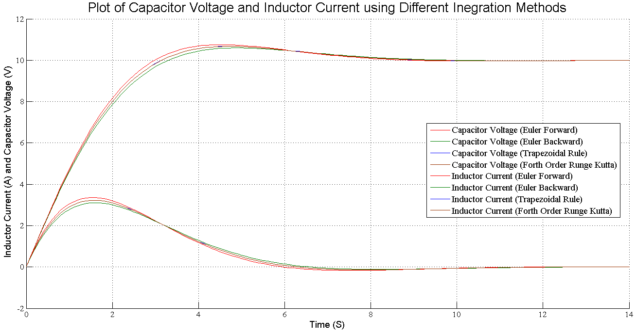
Figure 1 – A graph of integration methods simulating the transient waveforms of a RL circuit

References

[1] | A. Monti and A. Smith, "ELCT 302 Real Time Systems Desgin Laboratory Syllabus," Fall 2008. [Online]. Available: http://www.ee.sc.edu/classes/Fall08/elct401/.

